|  |  |
| --- | --- |
|  | **FPT ACADEMY INTERNATIONAL**  **FPT – APTECH COMPUTER EDUCATION**  **Address: 590 Cach Mang Thang 8, District 3, Ho Chi Minh City, Viet Nam.** |
| **An Thang Camera**  **Development’s Guide**  April 2019 | |
| |  |  |  | | --- | --- | --- | | **Supervisor** | Ngo Phuoc Nguyen | | | **Semester** | IV | | | **Batch No.** | T1.1904.E0 | | | **Group No.** | 2 | | | **Member No.** | **Full Name** | **Roll No.** | | 1 | Tran Van Minh Chien | Student1016716 | | 2 | Duong Tan Phu | Student1016698 | |  |  |  | |  |  |  | | |
|  | |
|  | |

Table of Contents

REVIEW 1 4

A. Introduction 5

B. Requirements 5

B.1 RS (Customer requirement specification) 5

B.2 Functional requirements 5

B.2.1 Back End - Login Page: 5

B.2.2 Back End - General Management Page: 5

B.2.3 Back End - Order Page 6

B.2.4 Back End - Product: 6

B.2.5 Back End - Customer Management Page: 6

B.2.6 Back End - Promotional Products: 7

B.2.7 Back End - Report Page: 7

B.2.8 Back End - Account Management Page: 7

B.2.9 Back End - Content Page: 7

B.2.10 Front End - Page Overview of Comments, Rating: 8

B.2.11 Front End - Home Page: 8

B.2.12 Front End - Product Details Page: 8

B.2.13 Front End - Category Page: 9

B.2.14 Front End - Registration Page: 9

B.2.15 Front End - Customer Information Page: 9

B.2.16 Front End - Cart Page: 9

B.2.17 Front End - Payment Page: 9

B.2.18 Front End - Page to View the Purchase Order: 10

B.2.19 Front End - Contact Page: 10

B.2.20 Front End - Blogs Page: 10

B.3 System requirements 10

B.3.1 Server Requirements 10

B.3.2 Client Requirements 11

TaskSheet Review 1 13

REVIEW 2 14

A. Use Case 15

B. Data Flow Diagram (DFD) 16

B.1 Context Diagram 16

B.2 DFD Level 1 17

B.2.1.1 Login 17

B.2.1.2 Registration 17

B.2.1.3 Product 18

B.2.1.4 Order 18

B.2.1.5 Rating/Comment 19

B.2.1.6 Cart Item 19

B.2.1.7 Wishlist 19

B.2.1.8 Report 19

C. Sequence Diagram 20

C.1 SKUD, Search Product 20

C.2 Login 23

C.3 Register 23

C.5 SKUD Category 25

C.6 SKUD Order 26

C.7 Comment/Rating 29

C.8 Report 31

D. Entity Relationship Diagram (ERD) 32

D.1 Diagram 32

D.2 Account 32

D.3 Category 33

D.4 Product 33

D.5 Camera 34

D.6 DVR 34

D.8 OrderDetails 35

D.9 Wishlist 35

D.10 Customer 36

D.11 Rating 36

TaskSheet Review 2 37

REVIEW 3 38

A. Sitemap 39

A.1 User - Home Page 39

A.2 Admin – Dashboard 40

B. Screenshot 41

B.1 User - Home Page 41

B.2 Admin Dashboard 49

TaskSheet Review 3 61

|  |
| --- |
| REVIEW 1 |

1. Introduction

Due to current technological advances, more and more electronic devices appear and the need to buy and learn about electronic devices such as security cameras. Therefore, Camera Shop was born to solve this problem. Camera Shop is an online shopping application provided by Camera company. Camera shops help customers see information and purchase many camera models anytime, anywhere with just one phone or laptop connected Internet.

1. Requirements
   1. RS (Customer requirement specification)

- The system allows the customer to view detailed information about the products.

- Customers can find products by name or filter products by categories, brands and prices.

- The system allows the customer to compare between many products with the same type so that they can choose the most suitable product.

- The system allows customers to create new accounts.

- Customers with their accounts have the permission to manage personal information, add products to their favourites and evaluate the products.

- The system has the shopping cart which supports customers to order the products anytime, anywhere.

- The customer who does not login to the system still also can order the products.

- Administrators have permission to manage the products, user accounts, etc.

- Administrators can export store activity reports based on sales revenue, number of products sold, etc.

* 1. Functional requirements
     1. Back End - Login Page:
        1. Description:

- The shop owner logs into the admin page by accessing the domain / admin. The page has a function that links to the password reset page.

* + - 1. Details

- Shop owner and administrator log in with the shop owner's email, (used to retrieve the password when lost).

- If entered incorrectly, it will show "Username or password incorrect".

- When the wrong input is more than 5 times will be locked, if the wrong administrator's input will contact the shop owner, the shop owner will be wrong to contact the developer.Back End-General Management Page:

* + 1. Back End - General Management Page:
       1. Description:

- General management page" is a page that gives you a quick and general overview of your website's situation in a predetermined period of time, including: access trends, revenue, growth of your online store. and allows you to track all activity through the general management screen.

* + - 1. Details

- After successful login, you will be directed to the "General Management" page.

- The list of the most purchased products on the website will be fully displayed here.

- You can click on each subfolder to see the activity in each group, including: see all the activities, the shop's activities, the staff members.

- List of site administrators' activities: All activities to edit content, update prices, add new products ... of the site administrator will be displayed here. Active applications include: User name, activity (what has been done), exact time for each activity.

* + 1. Back End - Order Page
       1. Description:

- The owner shop manages all orders in the Order section of the Admin page.

- The Orders section in the Admin page includes three management items: All orders, Draft orders, and Incomplete order.

* + - 1. Details

Sellers can filter orders by order, see here all details in the order such as: Code, date, customer, delivery ... so on.

- Can view all status of orders.

- Draft orders so that sellers can create orders for customers, sellers can create draft orders

- Search and filter draft orders. The search bar supports sellers searching by draft order codes and customers.

- Incomplete order page: the seller can see that the customer has not completed the order and convinces them to return to order.

* + 1. Back End - Product:
       1. Description:

Shop owners can view, add, update and adjust all their products and versions on the Admin page.

* + - 1. Details

- Shop owners can view, add, delete and update all products and variants, calculated from the Product area.

- Manage inventory in the product area.

- Create product groups, manage product groups.

- Output list of files to .xls file (Excel).

- Search and filter the list of products.

* + 1. Back End - Customer Management Page:
       1. Description:

- Interaction with Buyers is an important part of running a business. Each time a new Customer orders with the Owner's shop, their name and other details are added to the customer list. The seller can review all customers and manage his customer information in the Customer section of the Admin page

-If the buyer creates an account with the store, they can add address information to their account so that it automatically fills in the payment process. They can also view their order history with the store and view the current order status for any purchases they make.

* + - 1. Details

-When a new customer orders at the store, their name and information will be automatically added to the customer list. Depending on the circumstances, Seller can also manually add, edit or delete. If a Seller wants to send a discount or send an email to a specific customer group, a group of customers can be created.

Note: By default, customer lists are sorted from new to old, with the latest customers at the top. The seller can sort the customer list by customer name, by location, by order quantity, or Total amount by double clicking on each title.

-Export customer list.

* + 1. Back End - Promotional Products:
       1. Description:

- Promotions support Shop launch promotions or discount codes to customers not only easy, professional but also good management.

- Create promotions to help increase sales revenue as well as support loyal customers.

- Can create promotions to apply direct discounts on each product sales, on invoices, on each customer group ...

* + - 1. Details

-Stop / delete promotions, filter promotion search, Create discounts in limited time.

* + 1. Back End - Report Page:
       1. Description:

-Report sales analysis to help shop owners learn about sales and buyers in the most detailed way.

-At the same time, shop owners can control the sales and purchase activities optimally. Aiming at improving and developing business.

* + - 1. Details

-Report sales by: current month, by year, by product, product - manufacturer, by region, Export sales report to .xls file).

-View and export financial statements.

* + 1. Back End - Account Management Page:
       1. Description:

-The owner account is the account of the person who created the website. This person has an email and contact information originally used to register.

* + - 1. Details

-When Shop's website needs more than one administrator, it is recommended that shop should issue a separate account for each person.

- By administering the administrator, the shop owner can allow employees to access the Asian admin page as well as set appropriate limits for each administrator. These administrator accounts operate independently and the

owner can easily review employee history and interaction about the administrator's history.

-Add, edit, delete administrator. Add, edit, delete administrator rights.

* + 1. Back End - Content Page:
       1. Description:

- Want to sell online effectively. The shop not only focuses on the product but also creates articles to add more information of the store to the Customer to increase the trust of the Buyers in the store.

* + - 1. Details

-Add, delete, edit Blogs page.

-Manage linked pages: introduction, return policy, security policy, terms of service, contact .... So on.

* + 1. Front End - Page Overview of Comments, Rating:
       1. Description:

- After the customer has purchased the product, the customer has the right to post his review of the product to the product details page. The content will be reviewed by the seller before being posted on the product details page.

- Note: do not browse the content of vandalism, curse shop, do not hide the content of positive feedback about the product.

* + - 1. Details

- Each comment has only 1 answer from the seller.

- Must wait for the seller to review, the new comment will show up on the shop's page.

- The commenter must leave his or her name, phone number, email.

- Ranking function only members can be rated.

* + 1. Front End - Home Page:
       1. Description:

- The first main page when customers visit the shop's website, the page displays the outstanding products, promotion products of the store.

* + - 1. Details

**Header**: including logo, favicon, header content. The two parts required for a homepage header are the logo and the favicon. Displays products viewed, search bar. Log out account.

**Body**: including sliders, banners, seasonal products, high-end products, promotional products. Pages will vary in content.

**Footer**: The columns of information at the bottom of the homepage. Common information in the footer is policy.

* + 1. Front End - Product Details Page:
       1. Description:

- When customers want to see details about products or want to buy products…

* + - 1. Details

- Page showing product information.

- Add products to the cart and like the product.

- Related products, Products combo, the products are purchased together.

* + 1. Front End - Category Page:
       1. Description:

- The products with the same common points will be placed in the general list of products for customers to buy goods for tracking purposes, for example, grouping into pants, shirt, brand….

* + - 1. Details

- Display many products of the same type.

- Sort by price, name, best seller.

- Display properties of products, suppliers, brands, related accessories, products viewed.

* + 1. Front End - Registration Page:
       1. Description:

- Visitors who want to buy long-term goods, receive promotions from the shop will register as a member of the shop.

* + - 1. Details

- Sign up by email, Facebook, Gmail, customer information, phone number.

- Send registration confirmation, password forgot via email.

* + 1. Front End - Customer Information Page:
       1. Description:

- Each customer when logged in has a separate information page, to manage customer details.

* + - 1. Details

- Manage products viewed.

- Profile customer: edit profile (password, phone number, delivery address…).

- The product has liked.

-Customer orders: status, history, order list printing.

* + 1. Front End - Cart Page:
       1. Description:

- Customers who have added products to the basket, the products will be displayed on this page.

* + - 1. Details

- Show all items added to the cart.

- Add quantity, delete added product

- Show price details, VAT.

* + 1. Front End - Payment Page:
       1. Description:

- When the product has a customer click on the payment button, this page will display information with delivery information, if the customer is a visitor will fill in the information, if the member information will be available. If you want to change your shipping address, you will fill in this. It will then go to the payment page.

* + - 1. Details

- Forms to enter customer information.

- Forms for confirming payment methods for orders and shipping fees.

* + 1. Front End - Page to View the Purchase Order:
       1. Description:

- When ordering, customer want to see the status on this page.

* + - 1. Details

- Displays the details of order, displays the situation as if it was delivered, ended, cancel.

* + 1. Front End - Contact Page:
       1. Description:

- Contact page is important in a website, acting as a bridge between buyers and sellers.

* + - 1. Details

- A full contact page consists of two parts:

+ Contact information: branch number, address, phone number, email …Address of the store on Google maps.

+ Show the change policy, security terms, store service shop.

* + 1. Front End - Blogs Page:
       1. Description:

- Blog posts: articles with rich content, with the division of categories and articles clearly. Sellers use blogs as a type of magazine or news site for websites.

* + - 1. Details

- Blogging is a great way to increase website visits and stop time at the website. From there, help increase sales opportunities for the Salesman.

- Shop can use blogs to:

- Announcement of promotion news.

- Industry news is on sale.

- Guide customers to use the product.

- Blog of the system is the same as the blog of other systems: it is possible to create categories to manage articles in different topics, and can optionally allow customers to comment or not in each article of the blog group.

* 1. System requirements
     1. Server Requirements
        1. Hardware:

|  |  |
| --- | --- |
| Component | Requirement |
| CPU | Processor type:  Pentium IV-compatible processor or faster  Processor speed:  Recommended: 2.0 GHz or faster |
| OS | Microsoft Windows Server 2012 with IIS 7 |
| Memory (RAM) | RAM:  Minimum: 3 GB  Recommended: 4 GB or more |
| Hard Drive | Free space:  Minimum: 20 GB  Recommended: 50 GB or more  Maximum: Operating system maximum |

* + - 1. Software

|  |  |
| --- | --- |
| Component | Requirement |
| NetBeans | NetBeans 8.2 |
| Software | Glass Fish 4.1.2, Java JDK 1.7 |
| RDBMS | Microsoft SQL Server 2012 |

* + - 1. Technology

|  |  |
| --- | --- |
| Component | Requirement |
| Front-End | HTML5, CSS3(sass, Bootstrap 3), JavaScript (JQuery), Ajax |
| Back-End | JSP, Session Bean … |

* + 1. Client Requirements
       1. Hardware

|  |  |
| --- | --- |
| Component | Requirement |
| CPU | Processor type:  Pentium III-compatible processor or faster  Processor speed:  Recommended: 2.0 GHz or faster |
| OS | All OS (Window, Linux, Android, Mac OS …) |
| Memory (RAM) | RAM:  Minimum: 3 GB  Recommended: 4 GB or more  Maximum: Operating system maximum |
| Hard Drive | Free space:  Minimum: 20GB |

* + - 1. Software

|  |  |
| --- | --- |
| Component | Requirement |
| Web Browser | IE 4.0, Firefox 3.0, Chrome or Higher |

* + - 1. Technology

TaskSheet Review 1

|  |  |  |  |  |  |  |  |  |  |  |  |  |  |  |  |  |  |  |  |  |  |  |  |  |  |  |  |  |  |  |  |  |  |  |  |  |  |  |  |  |  |  |  |
| --- | --- | --- | --- | --- | --- | --- | --- | --- | --- | --- | --- | --- | --- | --- | --- | --- | --- | --- | --- | --- | --- | --- | --- | --- | --- | --- | --- | --- | --- | --- | --- | --- | --- | --- | --- | --- | --- | --- | --- | --- | --- | --- | --- |
| |  |  |  |  |  |  | | --- | --- | --- | --- | --- | --- | | **Project IV** | | **Date of Preparation of Activity Plan** | | | | | **No.** | **Task** | **Actual Start Date** | **Actual Days** | **Team Members Name** | **Status** | | 1 | Problem definition | 20/04/19 | 22/04/19 | All Member | Completed | | 2 | Describe the system requirements of front-end | 20/04/19 | 22/04/19 | Completed | | 3 | Detailed the system requirements of front-end | 20/04/19 | 22/04/19 | Completed | | 4 | Describe the system requirements of back-end | 20/04/19 | 22/04/19 | Completed | | 5 | Detailed the system requirements of back-end | 20/04/19 | 22/04/19 | Completed | | 6 | System requirements | 20/04/19 | 22/04/19 | Completed | |
| |  |  |  | | --- | --- | --- | | **Leader** |  | **Instuctor** | |  |  |  | | Duong Tan Phu |  | Ngo Phuoc Nguyen | |
| REVIEW 2 |

1. Use Case

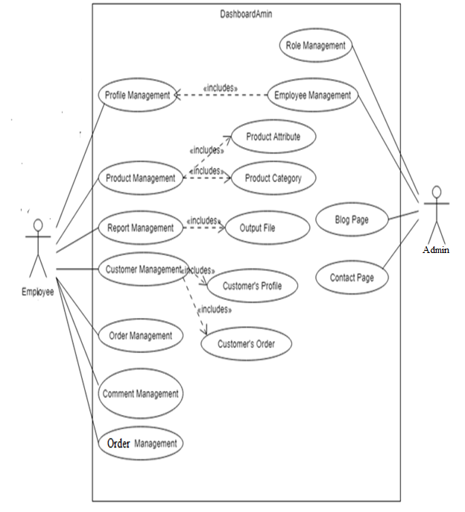

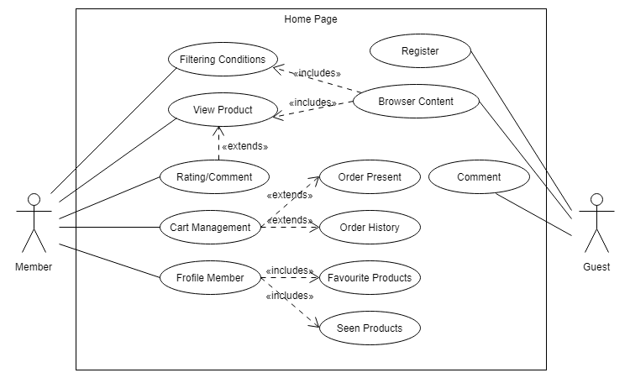

1. Data Flow Diagram (DFD)
   1. Context Diagram

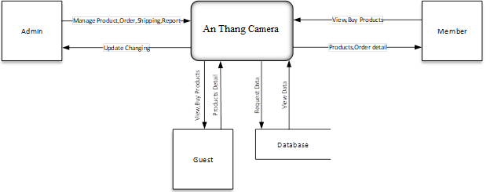

* 1. DFD Level 1
     + 1. Login



* + - 1. Registration



* + - 1. Product



* + - 1. Order



* + - 1. Rating/Comment



* + - 1. Cart Item

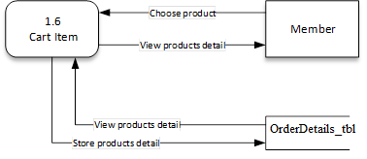

* + - 1. Wishlist



* + - 1. Report



1. Sequence Diagram
   1. SKUD, Search Product





* 1. Login



* 1. Register



* 1. Update Pro
  2. SKUD Category



* 1. SKUD Order





* 1. Comment/Rating





* 1. Report



1. Entity Relationship Diagram (ERD)
   1. Diagram

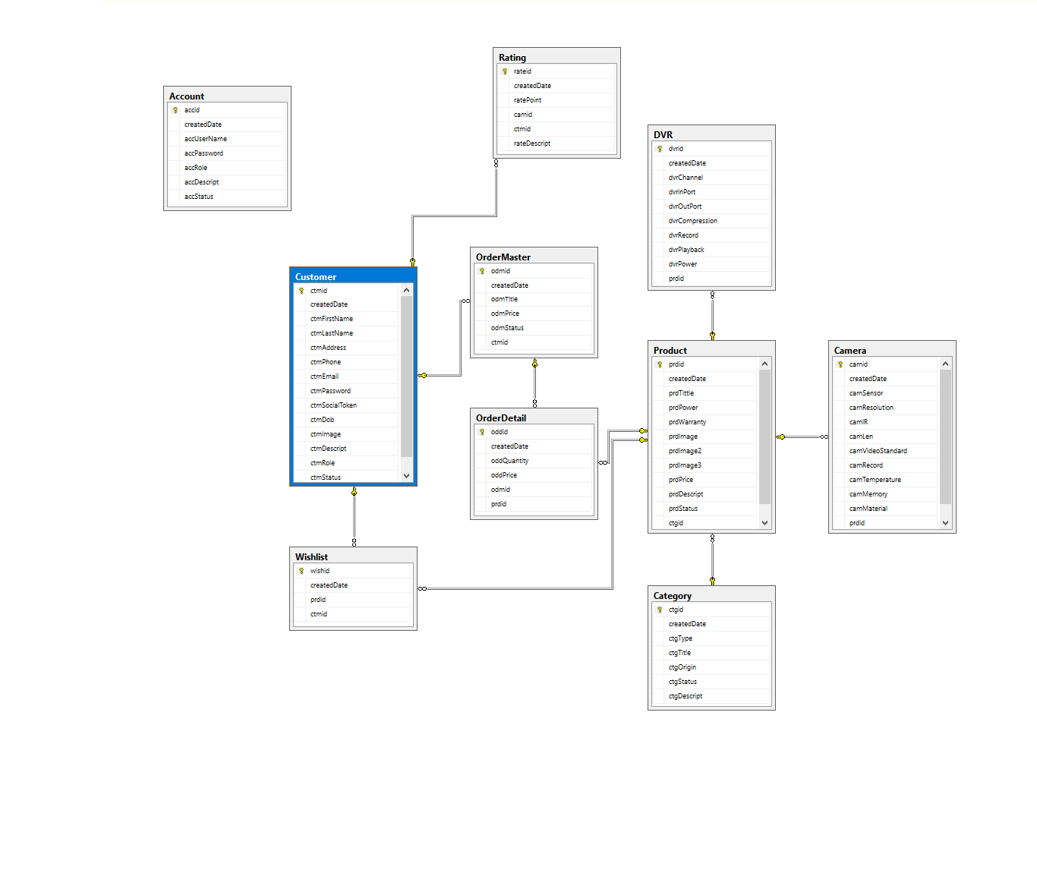

* 1. Account

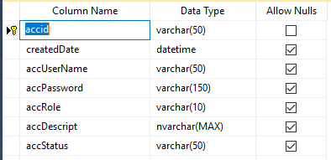

* 1. Category

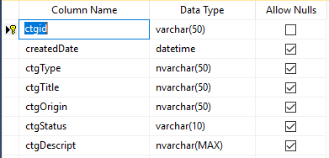

* 1. Product

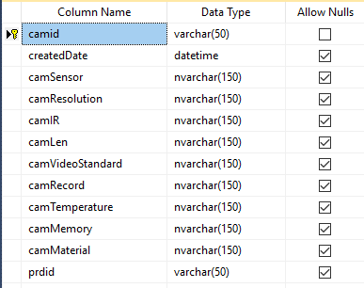

* 1. Camera

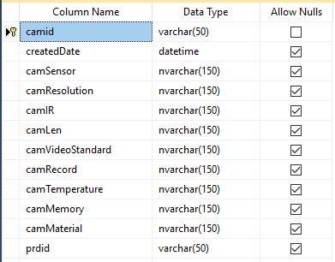

* 1. DVR

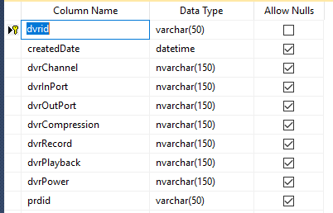

* 1. OrderMaster

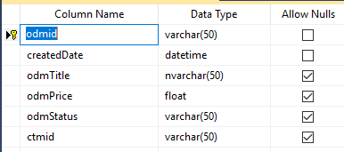

* 1. OrderDetails

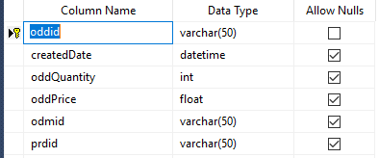

* 1. Wishlist

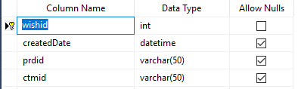

* 1. Customer

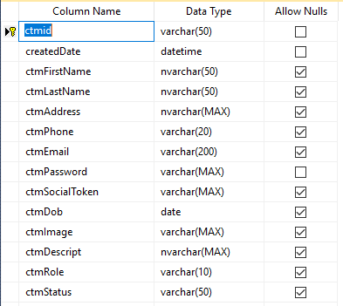

* 1. Rating

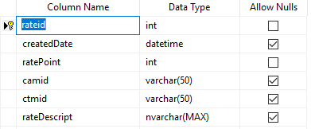

TaskSheet Review 2

|  |  |  |  |  |  |  |  |  |  |  |  |  |  |  |  |  |  |  |  |  |  |  |  |  |  |  |  |  |  |  |  |  |  |
| --- | --- | --- | --- | --- | --- | --- | --- | --- | --- | --- | --- | --- | --- | --- | --- | --- | --- | --- | --- | --- | --- | --- | --- | --- | --- | --- | --- | --- | --- | --- | --- | --- | --- |
| |  |  |  |  |  |  | | --- | --- | --- | --- | --- | --- | | **Project IV** | | **Date of Preparation of Activity Plan** | | | | | **No.** | **Task** | **Actual Start Date** | **Actual Days** | **Team Members Name** | **Status** | | 1 | User Case | 19/04/2019 | 19/02/2019 | All Member | Completed | | 2 | Data Flow Diagram | 19/04/2019 | 19/02/2019 | Completed | | 3 | Sequence Diagram | 19/04/2019 | 19/02/2019 | Completed | | 4 | Entity Relationship Diagram | 19/04/2019 | 19/02/2019 | Completed | |
| |  |  |  | | --- | --- | --- | | **Leader** |  | **Instuctor** | |  |  |  | | Duong Tan Phu |  | Ngo Phuoc Nguyen | |

|  |
| --- |
| REVIEW 3 |

1. Sitemap
   1. User - Home Page

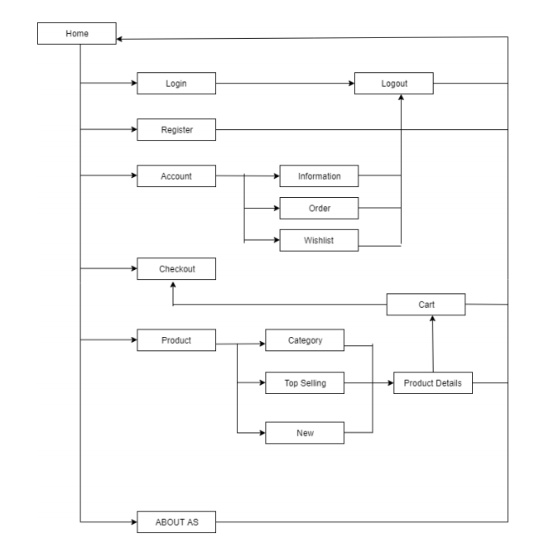

* 1. Admin – Dashboard

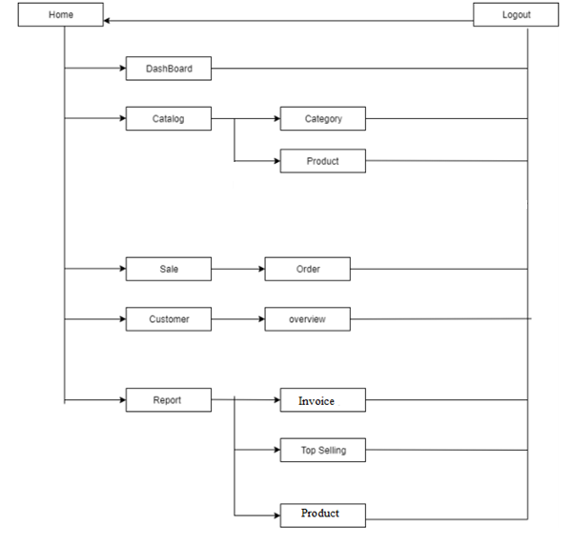

1. Screenshot
   1. User - Home Page
      1. Home Page

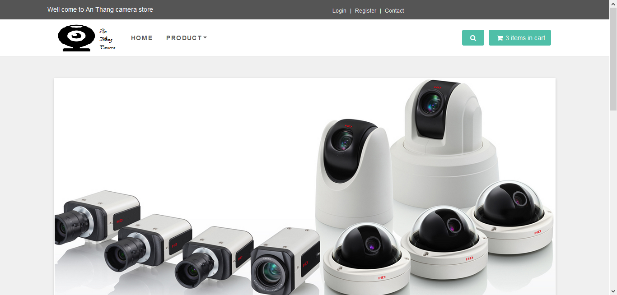

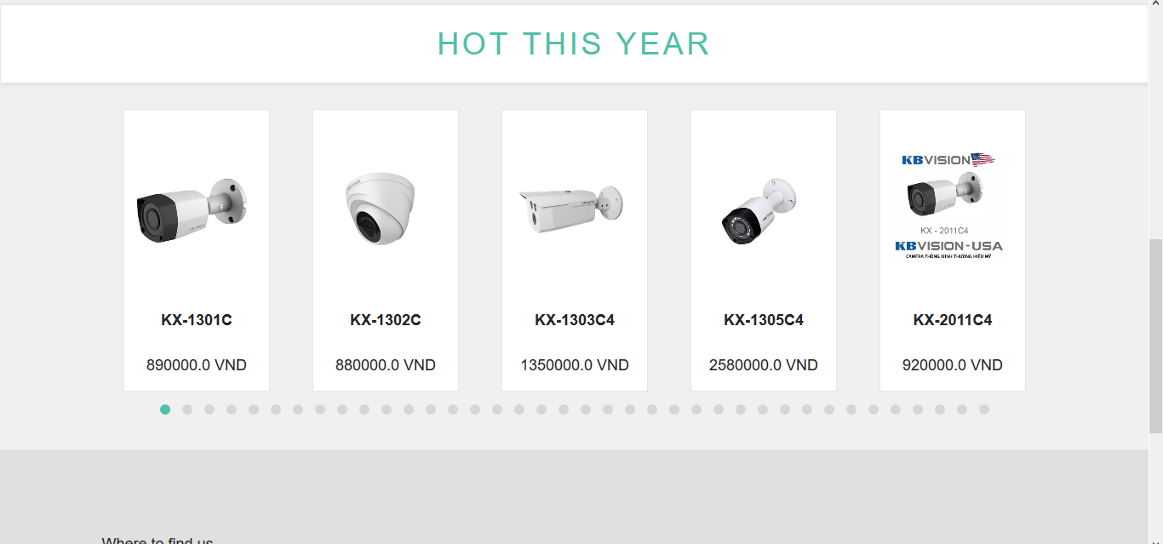

|  |  |  |  |  |
| --- | --- | --- | --- | --- |
| **No** | **Name** | **Type** | **Validation** | **Description** |
| **1** | Search Products | Input Text |  | Search Product by keyword |
| **2** | Login | Link |  | Linking to Login Page |
| **3** | Register | Link |  | Linking to Register Page |
| **4** | Contact | Link |  | Linking to Contact Page |
| **5** | ShoppingCart | Link |  | Linking to Cart Item Page |
| **7** | Product | Link |  | Linking to Product Page |
| **8** | About Us | Link |  | Linking to News Page |

* + 1. Login

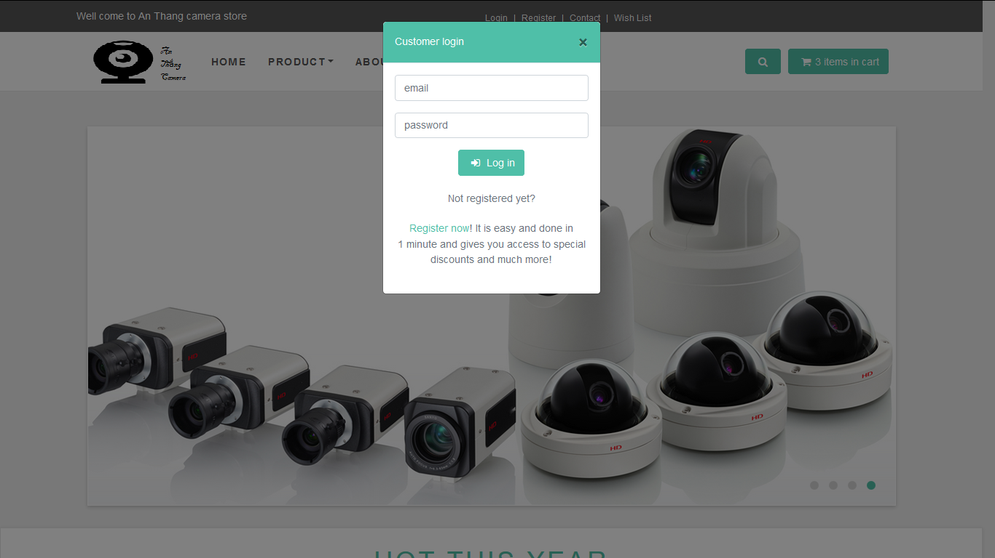

|  |  |  |  |  |
| --- | --- | --- | --- | --- |
| **No** | **Name** | **Type** | **Validation** | **Description** |
| **1** | Email | Input Text | Basic |  |
| **2** | Password | Password | Basic |  |
| **3** | Register Now | Link |  | Linking to Register Page |

* + 1. Register

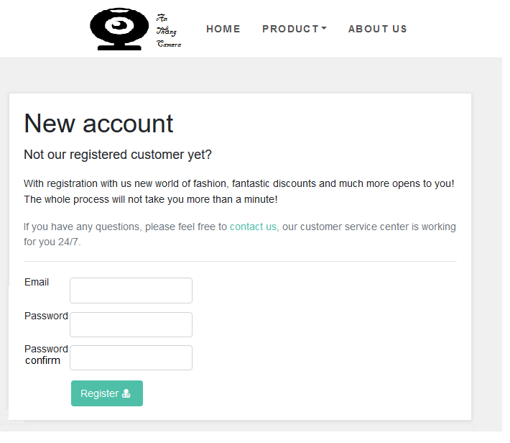

|  |  |  |  |  |
| --- | --- | --- | --- | --- |
| **No** | **Name** | **Type** | **Validation** | **Description** |
| **1** | Email | Input Text | -Check Database  -Valid Email |  |
| **2** | Password | Password | -Valid Pass |  |
| **3** | Confirm Password | Password | -Valid Confirm Pass |  |
| **4** | Register | Button |  | -Create Account |

* + 1. Contact

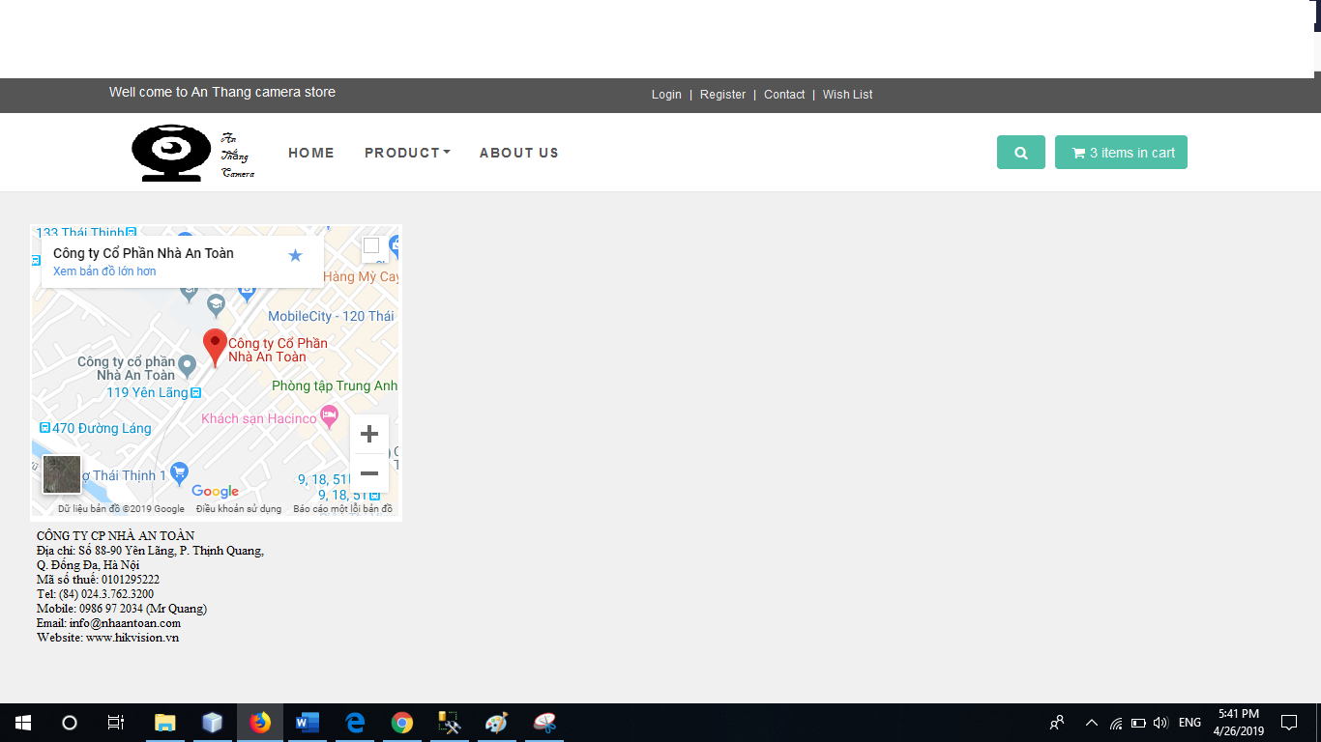

* + 1. Search Product
    2. Product Details

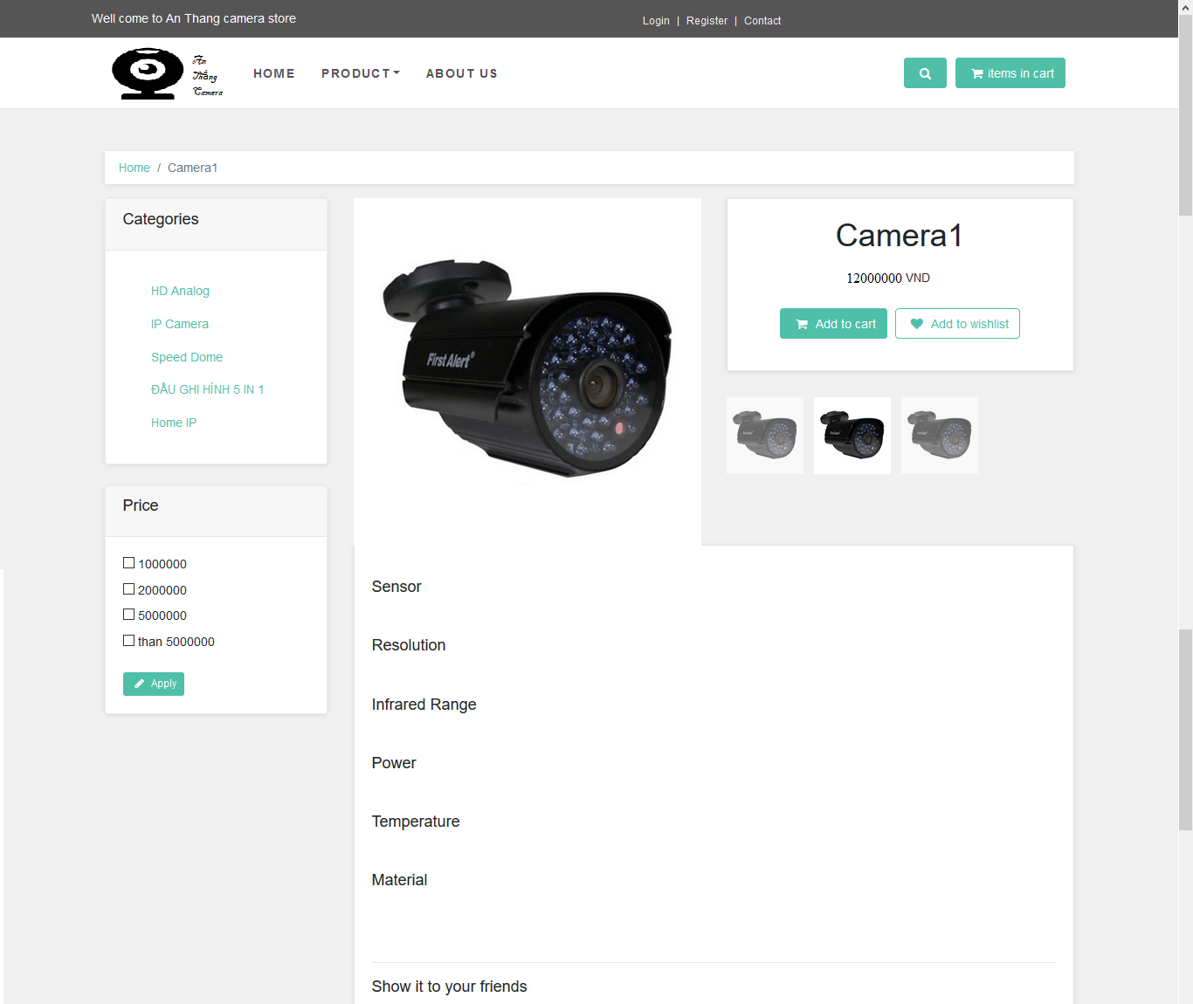

|  |  |  |  |  |
| --- | --- | --- | --- | --- |
| **No** | **Name** | **Type** | **Validation** | **Description** |
| **1** | Product Detail Page |  |  | -View Product Details |

* + 1. Shopping Cart

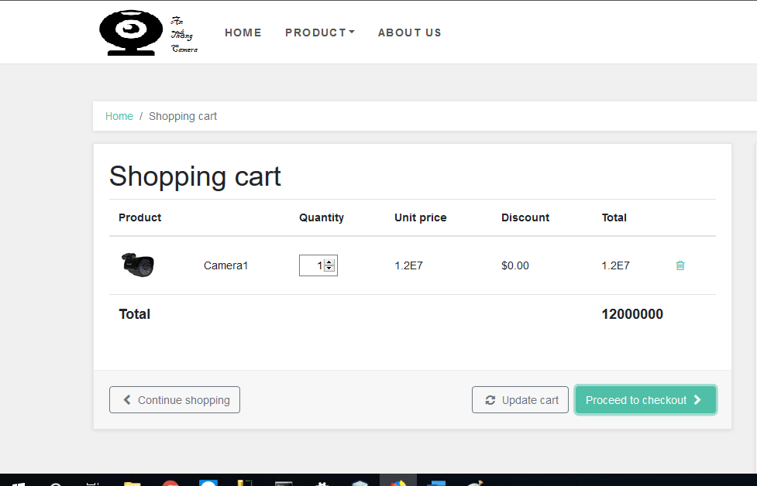

* + 1. Check out 1

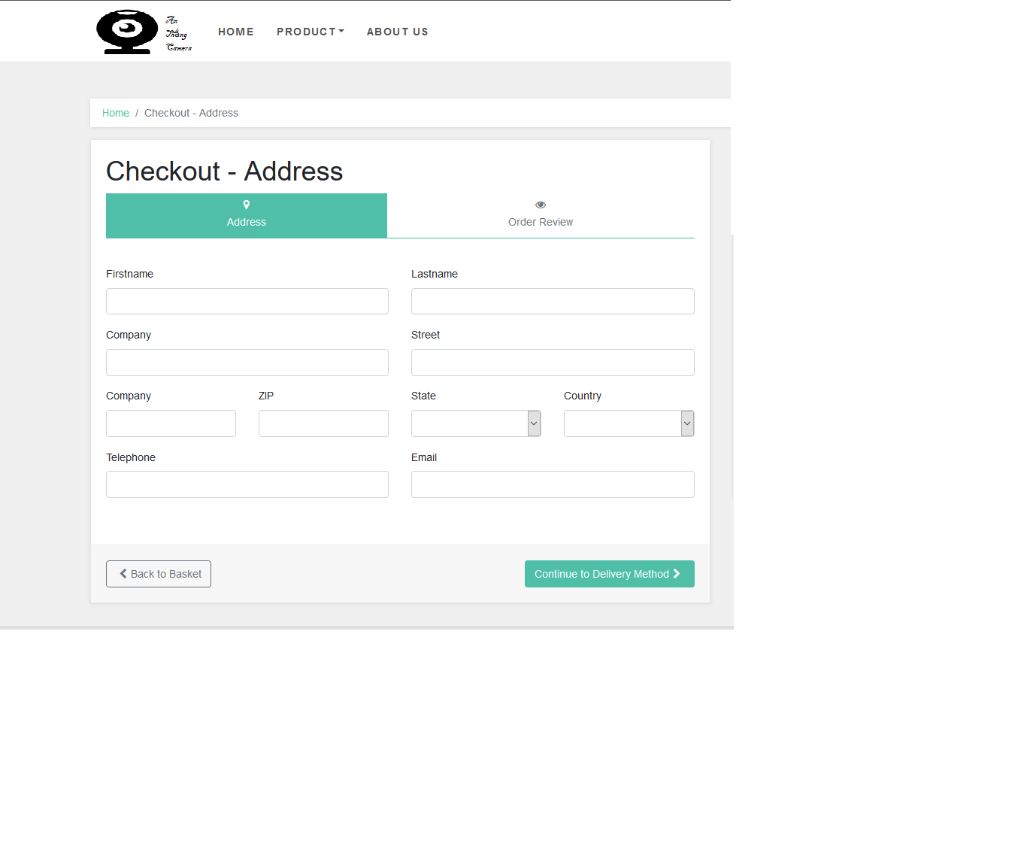

* + 1. Check out 2

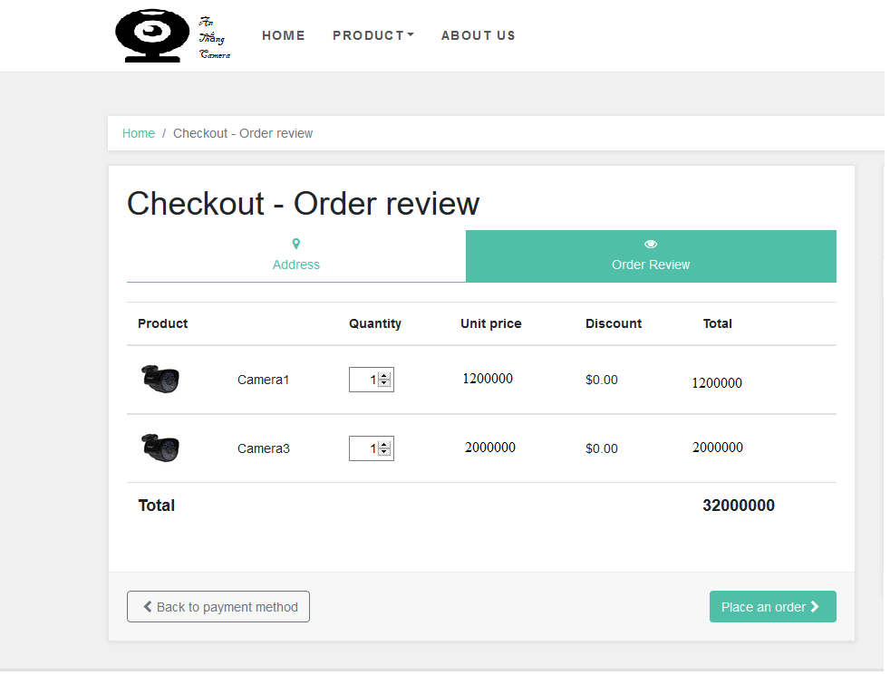

|  |  |  |  |  |
| --- | --- | --- | --- | --- |
| **No** | **Name** | **Type** | **Validation** | **Description** |
| **1** | Shopping Cart Page |  |  | -View All Products on Shopping Cart  -Can Add more product quantity  -Can Input Reduce Code  -View Invoice Details |

* + 1. Wishlist

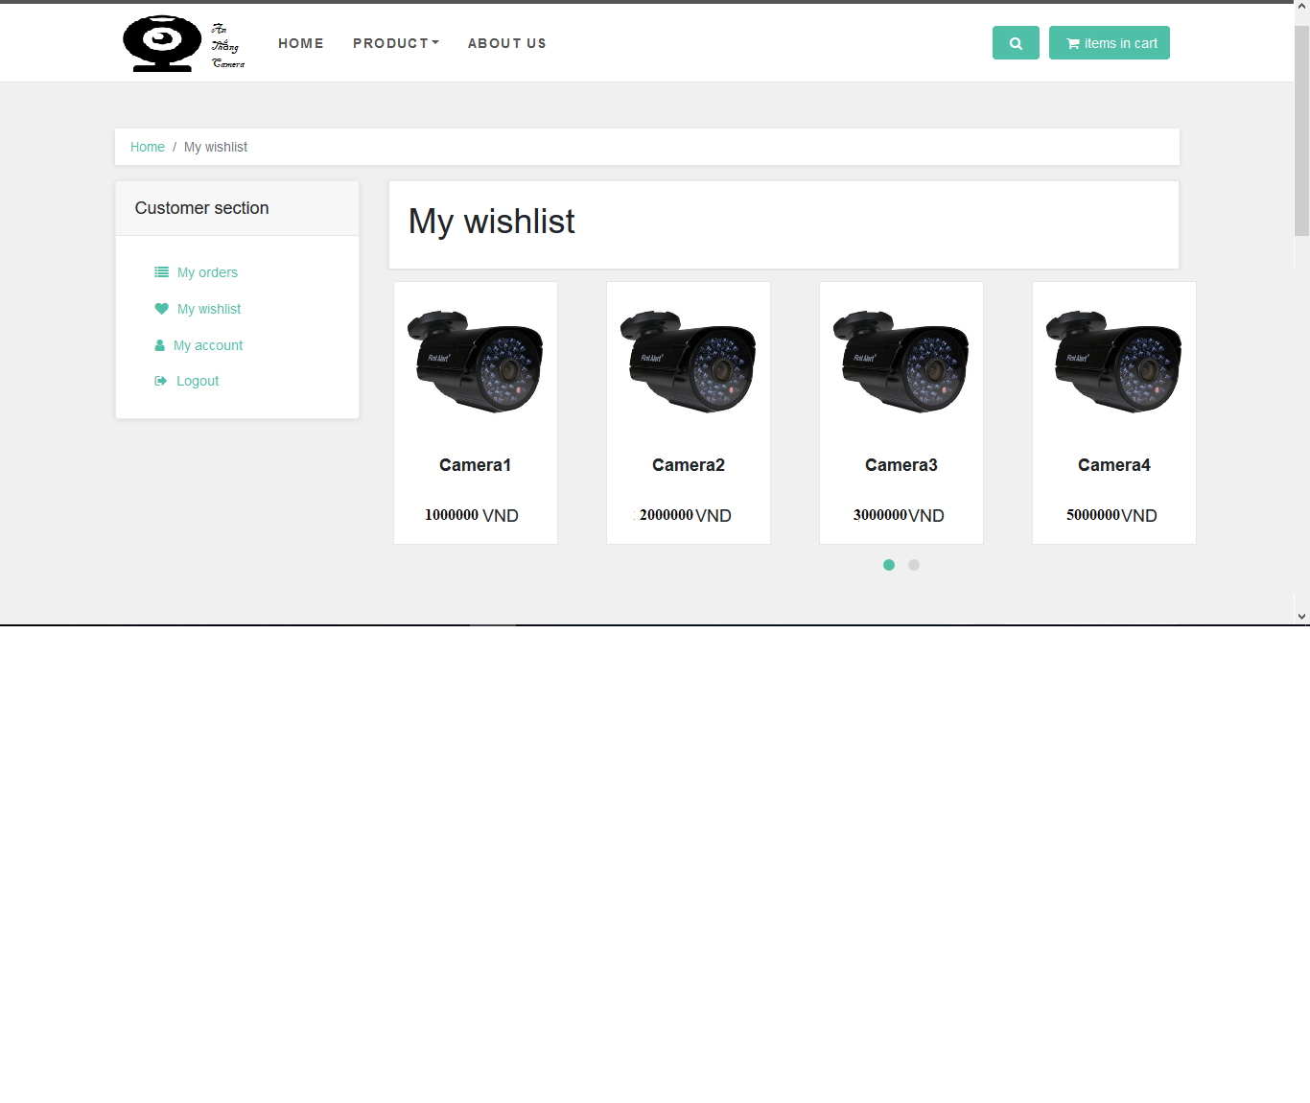

|  |  |  |  |  |
| --- | --- | --- | --- | --- |
| **No** | **Name** | **Type** | **Validation** | **Description** |
| **1** | WishList Page |  |  | -View All Products that Member Like |

* 1. Admin Dashboard
     1. Login

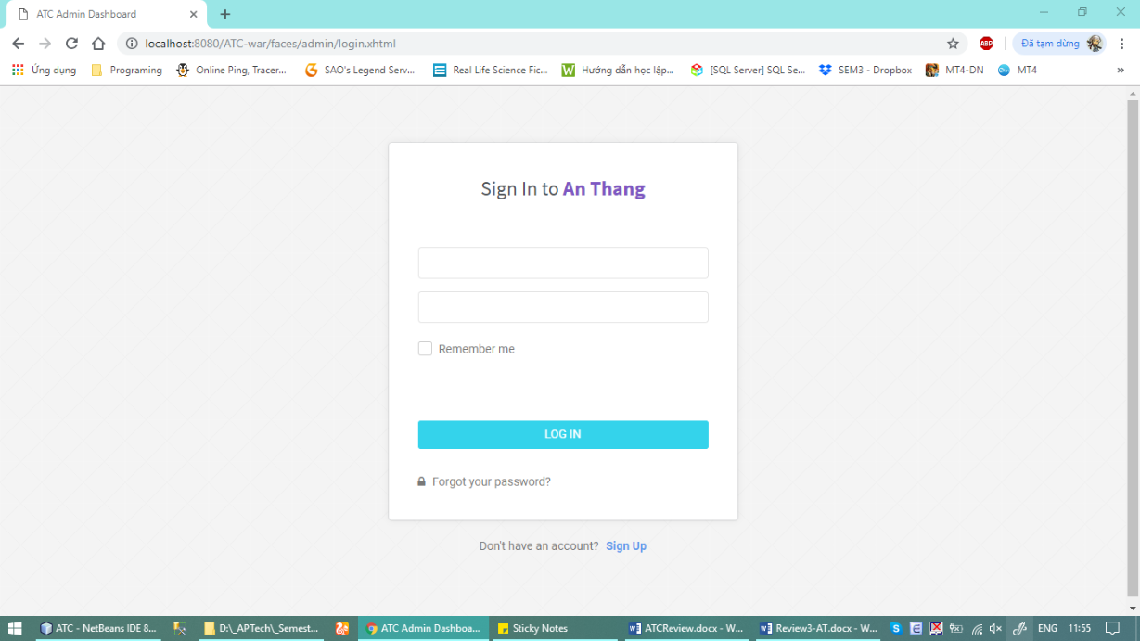

|  |  |  |  |  |
| --- | --- | --- | --- | --- |
| **No** | **Name** | **Type** | **Validation** | **Description** |
| **1** | Username | InputText | -ValidUserName |  |
| **2** | Password | Password | -ValidPassword |  |

* + 1. Dashboard

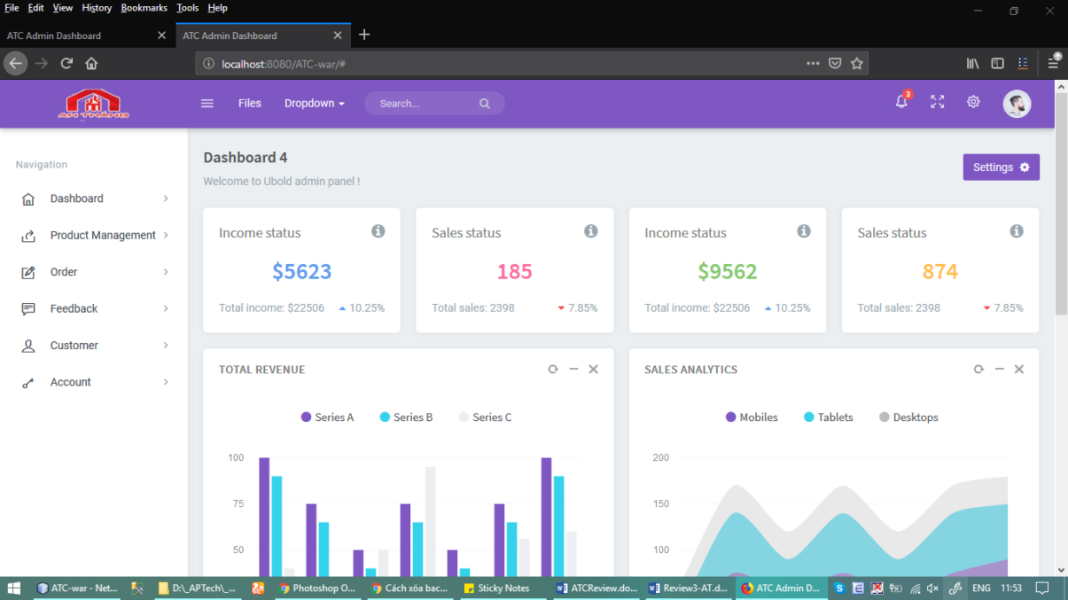

* + 1. Account View

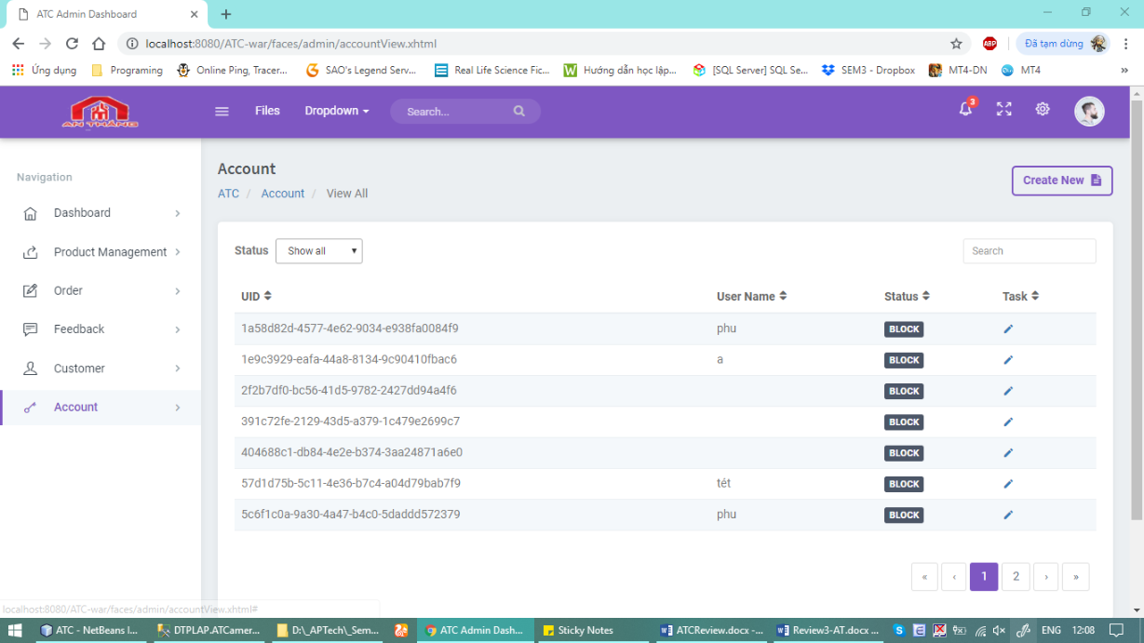

|  |  |  |  |  |
| --- | --- | --- | --- | --- |
| **No** | **Name** | **Type** | **Validation** | **Description** |
| **1** | Search Account by keyword | Input Text |  |  |
| **2** | Get All Account |  |  |  |

* + 1. Account Create

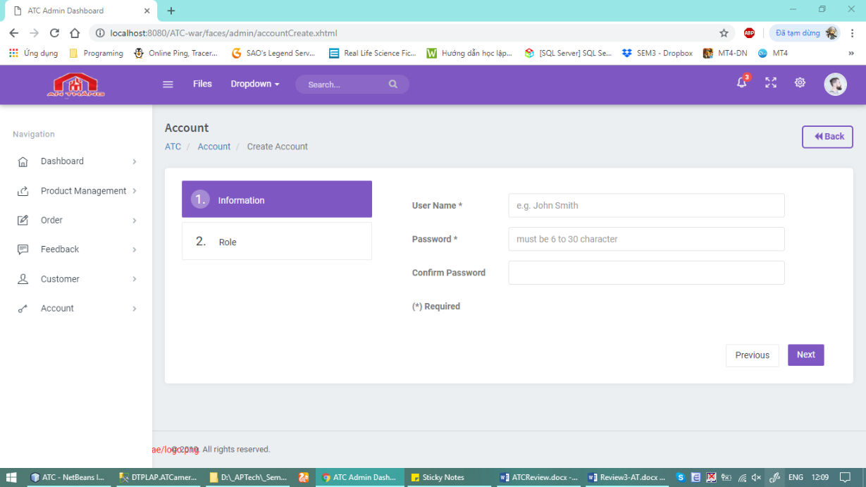

|  |  |  |  |  |
| --- | --- | --- | --- | --- |
| **No** | **Name** | **Type** | **Validation** | **Description** |
| **1** | Username | InputText | -CheckDatabase  -Valid UserName |  |
| **2** | Password | PassText | -Valid UserName |  |
| **3** | Confirm Password | PassText | -Check equals password |  |
| **4** | Next | Button |  | Go to 2. Role |
| **5** | Previous | Button |  | Go to Previous Page |
| **6** | Role | Combox | -Manager  -Admin |  |
| **7** | Finish | Button |  | Create New Account |

* + 1. Account Details/Update

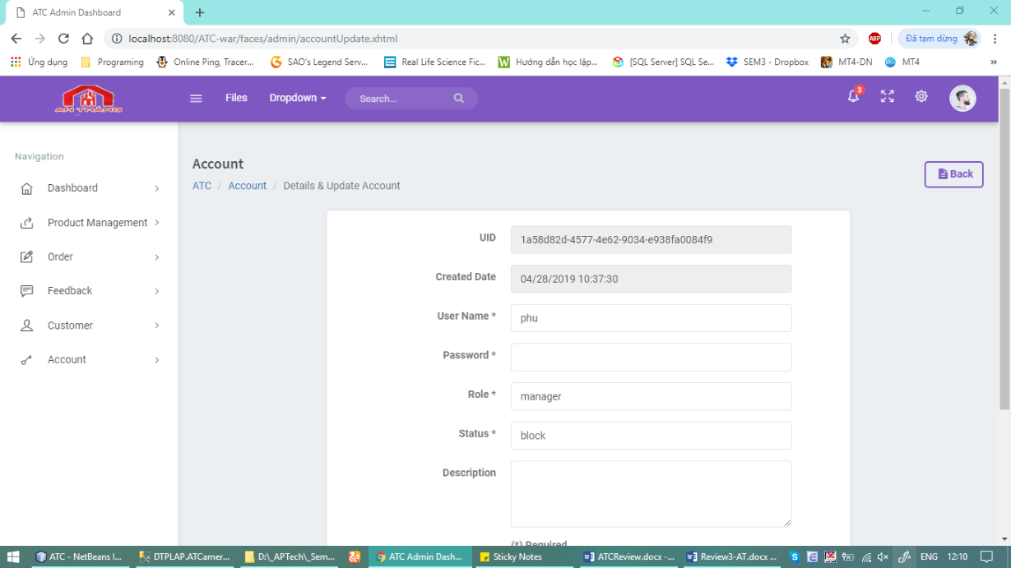

|  |  |  |  |  |
| --- | --- | --- | --- | --- |
| **No** | **Name** | **Type** | **Validation** | **Description** |
| **1** | Update Inform Account |  |  |  |

* + 1. Category View

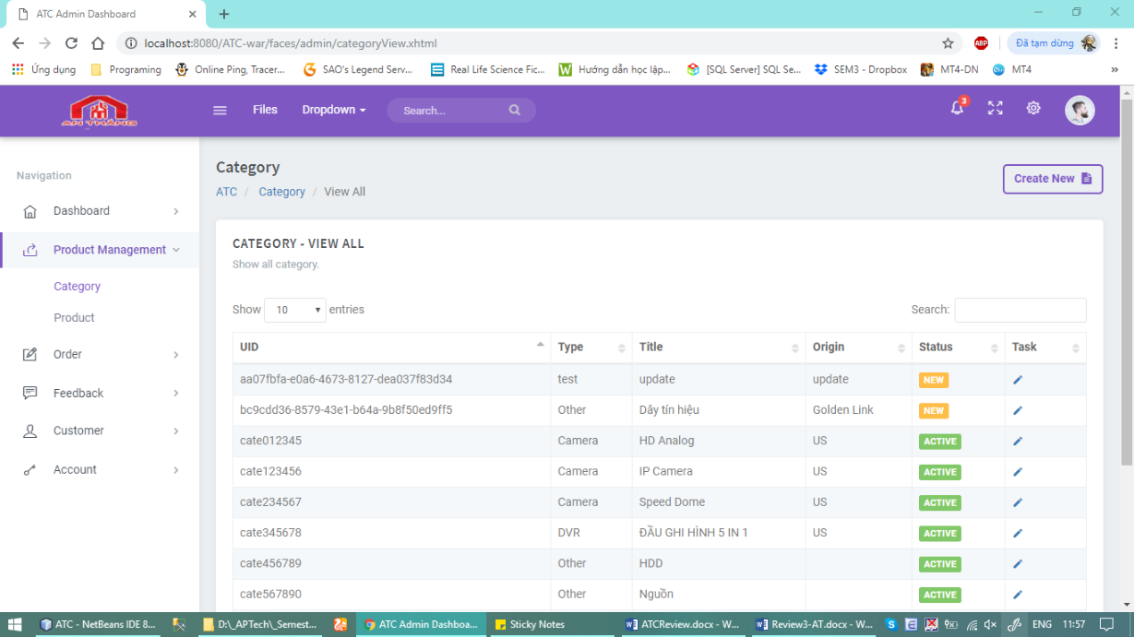

|  |  |  |  |  |
| --- | --- | --- | --- | --- |
| **No** | **Name** | **Type** | **Validation** | **Description** |
| **1** | Search Category |  |  |  |
| **2** | Get All Categories |  |  |  |

* + 1. Category Create

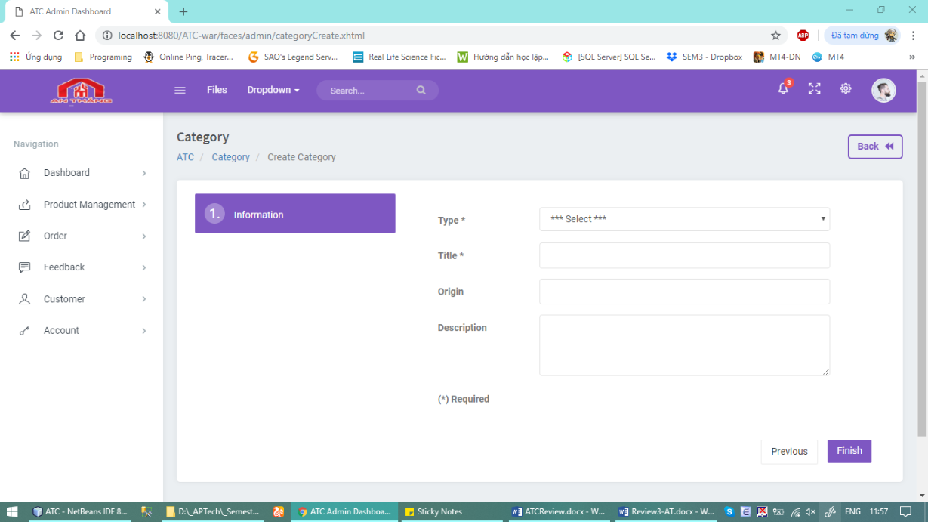

|  |  |  |  |  |
| --- | --- | --- | --- | --- |
| **No** | **Name** | **Type** | **Validation** | **Description** |
| **1** | Type | Combo box |  |  |
| **2** | Title | InputText | -Valid CtgTitle |  |
| **3** | Origin | InputText |  |  |
| **4** | Description | InputText |  |  |
| **5** | Create | Button |  | Create New Category |

* + 1. Category Details/Update

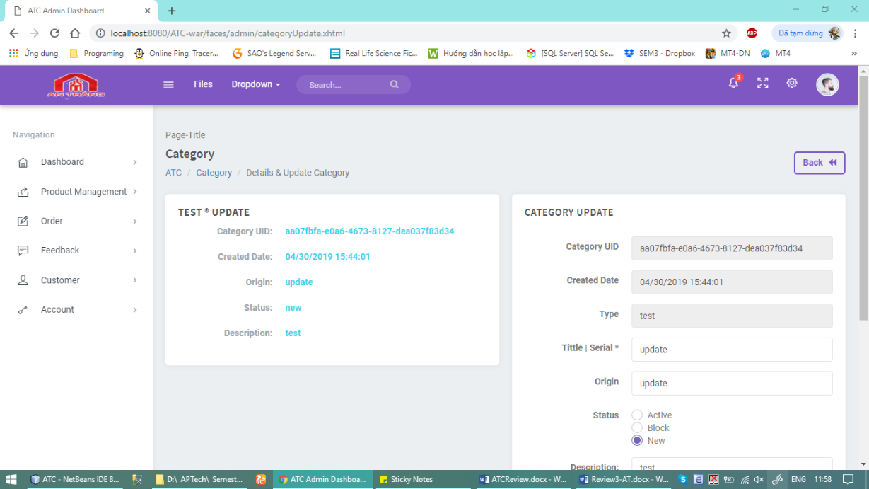

|  |  |  |  |  |
| --- | --- | --- | --- | --- |
| **No** | **Name** | **Type** | **Validation** | **Description** |
| **1** | Update Inform Account |  |  |  |

* + 1. Product View

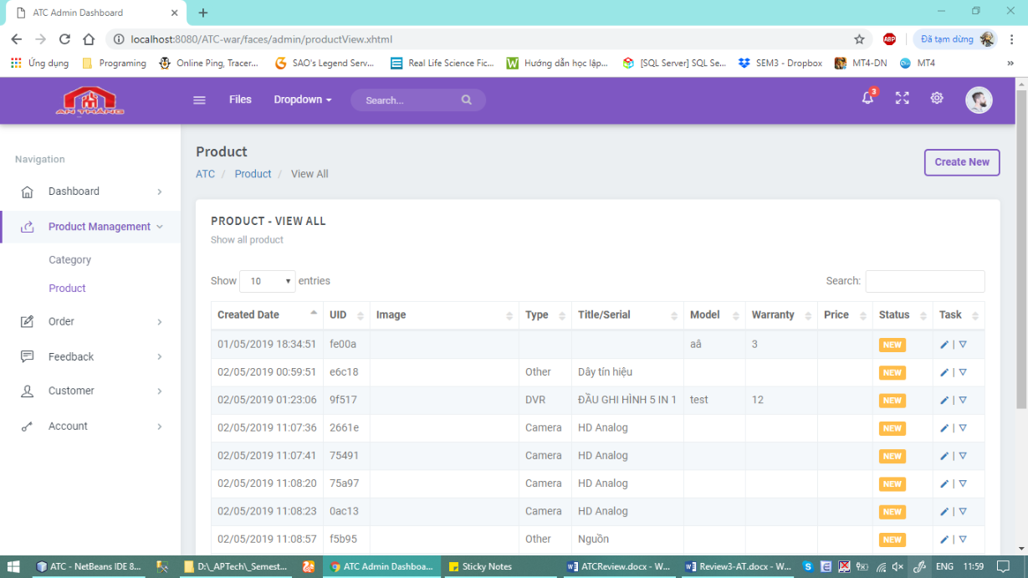

|  |  |  |  |  |
| --- | --- | --- | --- | --- |
| **No** | **Name** | **Type** | **Validation** | **Description** |
| **1** | Search Product |  |  |  |
| **2** | Get All Product |  |  |  |

* + 1. Product Create

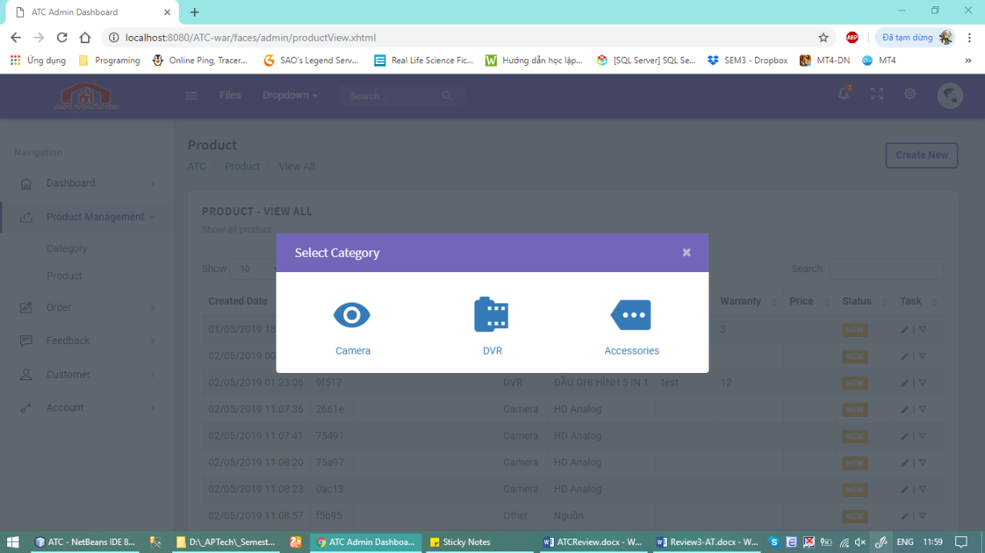

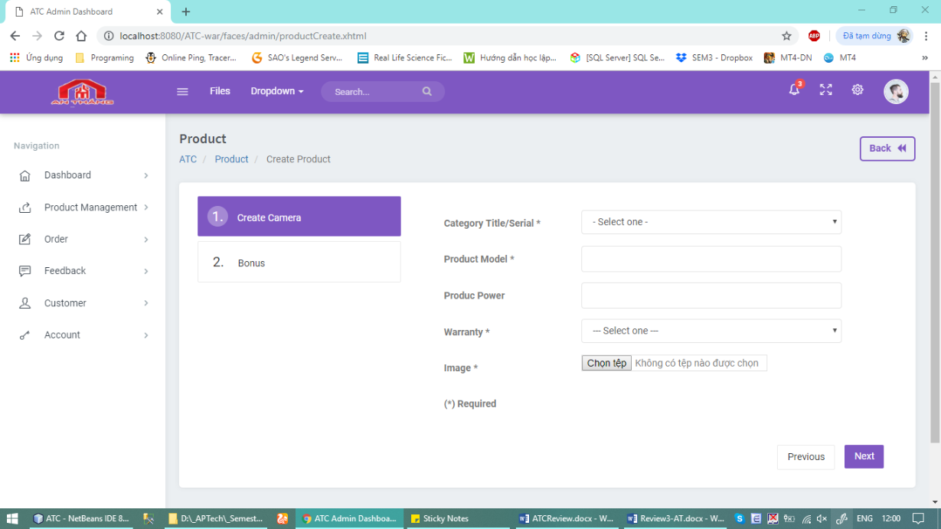

|  |  |  |  |  |
| --- | --- | --- | --- | --- |
| **No** | **Name** | **Type** | **Validation** | **Description** |
| **1** | Type Category | Buton |  |  |
| **1** | Category | Combo box | Select Ctg In Type |  |
| **2** | Product Model | InputText | -Valid PrdTitle |  |
| **3** | Product Power | Combo box |  |  |
| **4** | Image | File | NotNull |  |
| **5** | Next | Button |  | Go to 2. Bonus |
| **6** | Previous | Button |  | Go to Previous Page |
| **7** | The rest | InputText |  |  |
| **8** | Finish | Button |  | Create New Product |

* + 1. Product Details

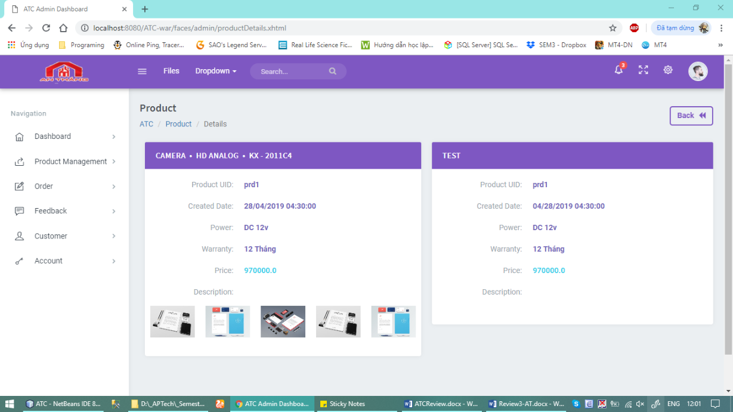

|  |  |  |  |  |
| --- | --- | --- | --- | --- |
| **No** | **Name** | **Type** | **Validation** | **Description** |
| **1** | Update Inform Product Details |  |  |  |

* + 1. Product Update
    2. Order View
    3. Order Update
    4. Feedback View
    5. Wishlish View
    6. Rating View
    7. Customer View

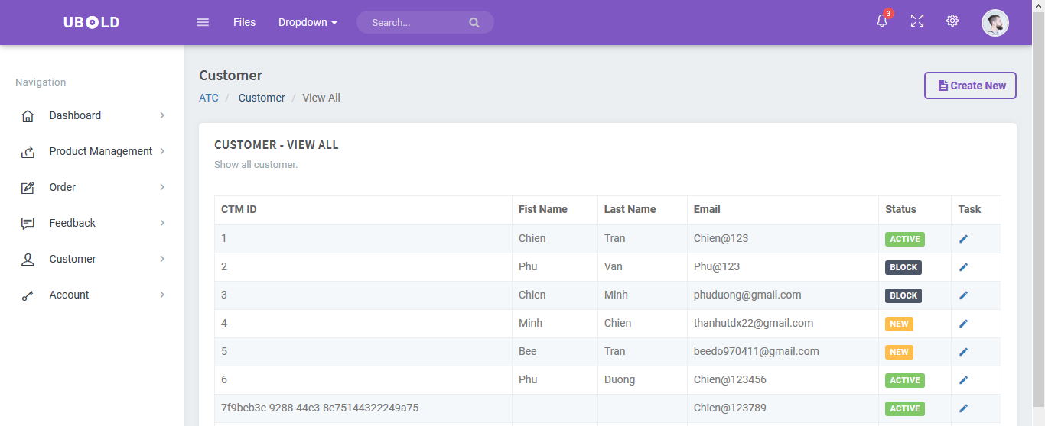

|  |  |  |  |  |
| --- | --- | --- | --- | --- |
| **No** | **Name** | **Type** | **Validation** | **Description** |
| **1** | Search Product |  |  |  |
| **2** | Get All Product |  |  |  |

* + 1. Customer Update
    2. Wishlist View

TaskSheet Review 3

|  |  |  |  |  |  |  |  |  |  |  |  |  |  |  |  |  |  |  |  |  |  |  |  |  |  |  |  |  |  |  |  |  |  |  |  |  |  |  |  |  |  |  |  |  |  |  |  |  |  |  |  |  |  |  |  |  |  |  |  |  |  |  |  |  |  |  |  |  |  |  |  |  |  |  |  |  |  |  |  |  |  |  |  |  |  |  |  |  |  |  |  |  |  |  |  |  |  |  |  |  |  |  |  |  |  |  |  |  |  |  |  |  |  |  |  |  |  |  |  |  |  |  |  |  |  |  |  |  |  |  |  |  |  |  |  |  |  |  |  |  |  |  |  |  |  |  |  |  |  |  |  |  |  |  |  |  |  |  |  |  |  |  |  |  |  |  |  |  |  |  |  |  |  |  |  |  |  |  |  |  |  |  |  |  |  |  |  |  |  |  |  |  |  |  |  |  |  |  |
| --- | --- | --- | --- | --- | --- | --- | --- | --- | --- | --- | --- | --- | --- | --- | --- | --- | --- | --- | --- | --- | --- | --- | --- | --- | --- | --- | --- | --- | --- | --- | --- | --- | --- | --- | --- | --- | --- | --- | --- | --- | --- | --- | --- | --- | --- | --- | --- | --- | --- | --- | --- | --- | --- | --- | --- | --- | --- | --- | --- | --- | --- | --- | --- | --- | --- | --- | --- | --- | --- | --- | --- | --- | --- | --- | --- | --- | --- | --- | --- | --- | --- | --- | --- | --- | --- | --- | --- | --- | --- | --- | --- | --- | --- | --- | --- | --- | --- | --- | --- | --- | --- | --- | --- | --- | --- | --- | --- | --- | --- | --- | --- | --- | --- | --- | --- | --- | --- | --- | --- | --- | --- | --- | --- | --- | --- | --- | --- | --- | --- | --- | --- | --- | --- | --- | --- | --- | --- | --- | --- | --- | --- | --- | --- | --- | --- | --- | --- | --- | --- | --- | --- | --- | --- | --- | --- | --- | --- | --- | --- | --- | --- | --- | --- | --- | --- | --- | --- | --- | --- | --- | --- | --- | --- | --- | --- | --- | --- | --- | --- | --- | --- | --- | --- | --- | --- | --- | --- | --- | --- | --- | --- | --- | --- | --- | --- | --- | --- | --- |
| |  |  |  |  |  |  | | --- | --- | --- | --- | --- | --- | | **Project IV** | | **Date of Preparation of Activity Plan** | | | | | **No.** | **Task** | **Actual Start Date** | **Actual Days** | **Team Members Name** | **Status** | | User – Home Page | | | | | | | 1 | Home page | 25/04/2019 | 1 | Chien | Done | | 2 | Login Page | 25/04/2019 | 1 | Chien | Done | | 3 | Register Page | 25/04/2019 | 1 | Chien | Done | | 4 | Contact Page | 26/04/2019 | 1 | Chien | Done | | 6 | Product Detail | 26/04/2019 | 1 | Chien | Done | | 7 | Shopping Cart | 27/04/2019 | 1 | Phu | Done | | 8 | Shopping Cart (Chose Payment Method) | 27/04/2019 | 1 | Phu | Done | | 9 | Order Report | 27/04/2019 | 1 | Phu | Editing | | 10 | Order History Page | 27/04/2019 | 1 | Phu | Editing | | 11 | View Order Detail | 27/04/2019 | 1 | Phu | Editing | | 12 | Wish List Page | 28/04/2019 | 1 | Chien | Done | | Admin - Dashboard | | | | | | | 13 | Login | 29/04/2019 | 2 | Phu | Done | | 14 | Dashboard | 29/04/2019 | 2 | Phu | Editting | | 15 | Account View | 29/04/2019 | 2 | Phu | Done | | 16 | Account Create | 29/04/2019 | 2 | Phu | Done | | 17 | Acccount Details/Update | 29/04/2019 | 2 | Phu | Done | | 18 | Category View | 29/04/2019 | 2 | Chien | Editing | | 19 | Category Create | 29/04/2019 | 2 | Chien | Editing | | 20 | Category Details/Update | 29/04/2019 | 2 | Chien | Editing | | 21 | Product View | 29/04/2019 | 2 | Chien | Editing | | 22 | Product Create | 29/04/2019 | 2 | Chien | Editing | | 23 | Product Details |  |  | Chien |  | | 24 | Product Update |  |  | Chien |  | | 25 | Order View |  |  | Phu |  | | 26 | Order Update |  |  | Phu |  | | 27 | Customer View |  |  | Chien |  | | 28 | Customer Update |  |  | Chien |  | | 29 | Report |  |  | Chien |  | | 30 | Wishlist View |  |  | Chien |  | |
| |  |  |  | | --- | --- | --- | | **Leader** |  | **Instuctor** | |  |  |  | | Duong Tan Phu |  | Ngo Phuoc Nguyen | |